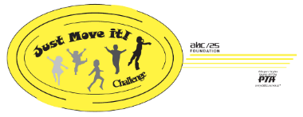

Thank you to all of the District 25 students who participated in the t-shirt and poster design contest! We had 32 t-shirt design entries and 22 poster design entries. We enjoyed looking at all of the creative ideas everyone came up with and you made it hard for us to choose. Voting for the race t-shirt design finished this past Friday and we are happy to announce that Design 2 drawn by Audrey of Olive-Mary Stitt was the winning design. Make sure you stop by our Facebook page https://www.facebook.com/JustMoveItChallenge/ or the Just Move It! Website www.jmichallenge.org to check out this year’s race t-shirt.
Early registration for the Just Move It! Challenge will opening up in the next couple of weeks! Remember that there are two participation awards given out each year for the elementary school and middle school that has the most student participation. Will your school be the one to bring it home this year? Be sure to register early and take advantage of the early registration discount.
Contact your school representative Mary Goumas (mgoumas@sd25.org) or Pam Sloss (ipojsloss@gmail.com) with questions or suggestions.
*All proceeds go to the Scholarship and Grant Fund, benefiting the education of School District 25 students through PTA scholarships and the ABC/25 Foundation Grant selection

