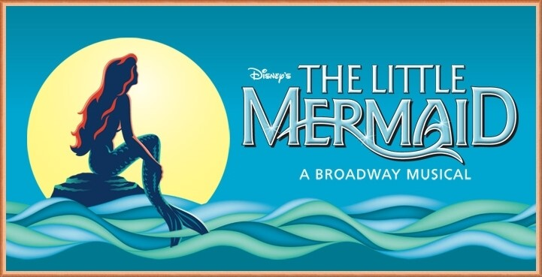
2017 Patton School 5th grade musical

To: __________________________________________________________________________
Patton School, in Arlington Heights District 25, has the distinct reputation within the community of excellence in the fine arts. This year, Patton’s 5th grade students, teachers, and parents have taken on the task of producing and performing in our own off-Broadway musical. This year, students will be entertaining audiences with one of Disney’s most beloved musicals from Broadway: The Little Mermaid . Patton’s musical production is the result of many hours of hard work and dedication of Patton’s students, teachers and parents.

Because of your reputation for supporting your community, students, and the arts, we are offering you an opportunity to become a “Patton School Patron of the Arts” by making a donation in support of our 2017 production of Disney’s The Little Mermaid. The performances are planned for May 23 and 25, 2017. As a sponsor, your business logo would appear in our program as a “Patron of the Arts.” This year, we anticipate handing out over 500 programs for the two performances. This is an outstanding opportunity for you to promote your business to a large audience in Arlington Heights and the surrounding communities. Please take a moment to consider a donation to support our students and their production.

If you are able to make a donation, please return the lower portion of this flyer with your check (made payable to Patton School) or cash to this address:

Patton School
c/o Casey Whitaker
1616 N. Patton Avenue
Arlington Heights, IL 60004

Thank you for taking the time to contribute to our students and their performance.

Sincerely,

Mr. Casey Whitaker
Music Director

__________________________________________________________________________________________
PATTON SCHOOL PATRON OF THE ARTS
Thank you for your tax-deductible contribution of:
_______$25.00 (Business Card) _______$50.00 (1/4 Page) _______$75.00 (1/2 Page)
_______$100.00 (Full Page) _____________Other (Please Specify Amount)
Business Name:_____________________________________________________________________________
Address:___________________________________________________________________________________
Phone:____________________________ Manager/Contact Person:__________________________________
Please enclose a logo, pre-printed advertisement or business card to be placed in our program.

