SAVE THE DATE FOR
TEACHNOLOGY
FAIR 2016
March 9th, 2016

District 25 and Arlington Heights Council of PTAs are hosting Teachnology 2016 at Thomas Middle School on March 9th, 2016 from 7-9pm

What is Teachnology:
This year District 25 and the Arlington Heights Council of PTAs will host an Education Fair with the theme of “Teachnology”. Students and Staff will have the opportunity to share with peers, parents and community members about how they use technology. This could mean teaching others a skill or simply sharing an experience using technology.

Ways to participate:
Classroom Session- A 15 minute presentation designed to teach the audience a particular skill or about a specific technology tool. Examples could include: How to use an app or computer program, how to create games, how they use technology in their classroom or demonstrations of programming. Limited to students in grades 3-8 or staff. Presenters may present individually, with a partner or a group.

Poster Session- Students can create a tri-fold presentation board, video or computer presentation to share an experience with technology. Students do not need a formal presentation, but should be prepared to answer questions. Examples could include: explaining how to play a video game, sharing an app, showing a “how-to” through a video presentation. Students of all grade levels or staff may participate. Presenters may present individually, with a partner or in a group.

Teachnology Guidelines:
Students and staff will be able to bring technology from home but will be responsible for set-up and staying with their devices during the event. All classroom sessions will be furnished with a computer and projector.

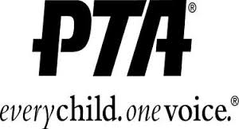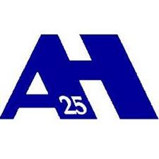

"Individuals with disabilities should notify the Building Principal if they have a disability that will require special assistance or services. Please give the building principal advance notice of 24 hours.”

