Dear Parents,
On October 18, we are excited to have Deb Skog, a local author come visit our school!
She will be sharing her new book, the Pumpkin Eating Dinosaur. It’s a fun fall story perfect for any child. Deb is a retired kindergarten teacher and she loves children and reading.
If you would like to order a signed copy of her HARDCOVER book, it will be delivered to your student on the day after her visit.
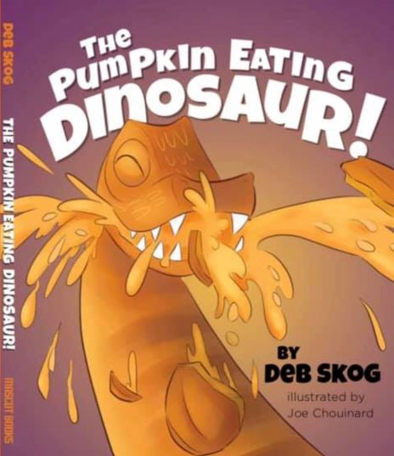
Chomp Chomp Chomp...
Roar Roar Roar...
It's The Pumpkin Eating Dinosaur!

It’s that time of year again!
Fall means pumpkins, but for Daniel and Trevor, it means visiting the pumpkin farm.
It’s a day filled with lots of fun things to do, but their favorite thing to see is
The Pumpkin Eating Dinosaur!
Enjoy reading about their visit and how they love watching him munch and crunch away!
An autographed copy is a perfect keepsake for any student!
To purchase, please return this order form with your payment by Tuesday October 15.
---------------------------------------------------------------------------------------------------------------------
AUTOGRAPHED BOOK ORDER FORM
Quantity______ $10 X_________ = Total Amount Enclosed $ ________________
Circle One: Cash Check (Make Checks payable to Deborah Skog)

Students’ Name ______________________________________________________________________

Personalization________________________________________________________________________

Teacher ___________________________________________________________________

